Final Report (Output)

**Connecting to database**

**Connection established**

----------------------------------------------------

**Total number of records:**

439

----------------------------------------------------

**States with their no of facilities:**

[('AL', 136), ('AZ', 1), ('CA', 83), ('DC', 23), ('LA', 17), ('MD', 32), ('MS', 27), ('OH', 35), ('TN', 3), ('TX', 10), ('VA', 60), ('WA', 12)]

----------------------------------------------------

**Latest Facility:**

[('31-03-2014', 'Mach 6, High Reynolds Number Facility')]

----------------------------------------------------

**States with their no of active facilities:**

[('AL', 118), ('AZ', 1), ('CA', 61), ('DC', 21), ('LA', 16), ('MD', 32), ('MS', 25), ('OH', 33), ('TN', 2), ('TX', 9), ('VA', 58), ('WA', 12)]

----------------------------------------------------

**Centers with their phone numbers:**

[('Air Force Research Laboratory', '937 255-1689'), ('Arnold Engineering Development Center', '(931) 454-6513'), ('Pacific Northwest National Laboratory', '509-372-6026'), ('Intelsat General', '424 206-2725'), ('Ames Research Center', '650 603-9506'), ('Armstrong Flight Research Center', '661-276-2585'), ('Glenn Research Center', '216-433-9370'), ('Goddard Space Flight Center', '301 286 2520'), ('Jet Propulsion Lab', '818.354.0701'), ('Johnson Space Center', '281.483.3219'), ('Langley Research Center', '757.864-3848'), ('Marshall Space Flight Center', '256-544-7795'), ('Michoud Assembly Facility', '504.257-2619'), ('NASA Aircraft Management Division', '202 358 4721'), ('Stennis Space Center', '601-688-1646'), ('Wallops Flight Facility/GSFC', '757-824-1120'), ('Orbital Satellite Manufacturing Facility - Arizona', '480 355 7275'), ('Raytheon Space and Airborne Systems - El Segundo', '310-647-4171')]

----------------------------------------------------

**Some Facilities with their Centers, Agencies and with the year Occupied:**

('DOD', 'Air Force Research Laboratory', 'Mach 6, High Reynolds Number Facility', 1960)

('DOD', 'Air Force Research Laboratory', 'Subsonic Aerodynamic Research Laboratory', 1985)

('DOD', 'Air Force Research Laboratory', 'Trisonic Gasdynamics Facility', 1960)

('DOD', 'Air Force Research Laboratory', 'Vertical Wind Tunnel', 1960)

('DOD', 'Arnold Engineering Development Center', '10V Test Chamber', 1965)

('DOD', 'Arnold Engineering Development Center', '7V Sensor Test Facility', 1994)

('DOD', 'Arnold Engineering Development Center', 'Mark I Aerospace Chamber', 1963)

('Intelsat', 'Intelsat General', 'Environmental Test Lab-Shaker', 1969)

('Intelsat', 'Intelsat General', 'Environmental Test Lab-Test Chamber ', 1969)

('Intelsat', 'Intelsat General', 'Large Anechoic Chamber ', 1969)

('Intelsat', 'Intelsat General', 'Outdoor Antenna Test Range ', 1969)

('Intelsat', 'Intelsat General', 'Scanning Auger Multiprobe; Electron Microscope ', 1969)

('Intelsat', 'Intelsat General', 'Semiconductor Fabrication 1 ', 1969)

----------------------------------------------------

**Visualization:**

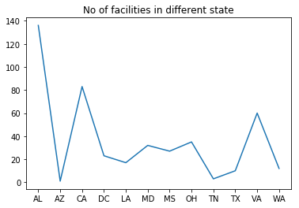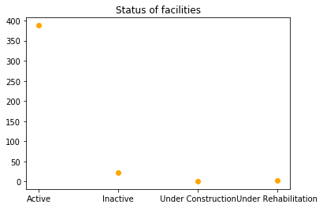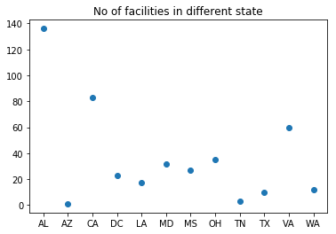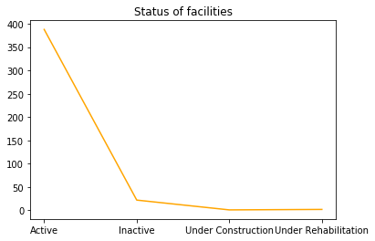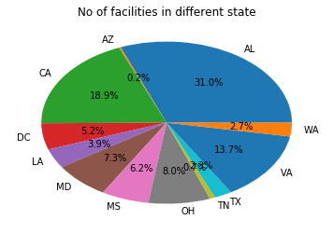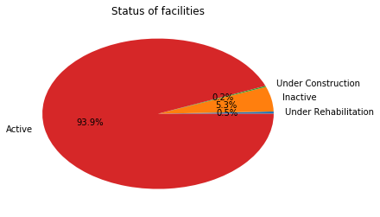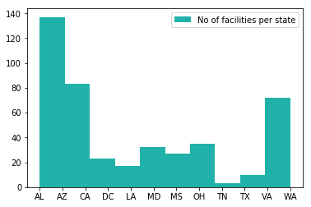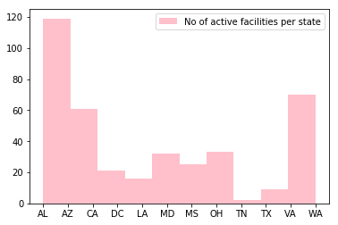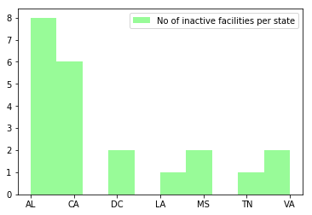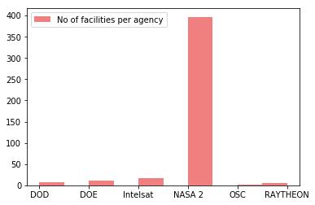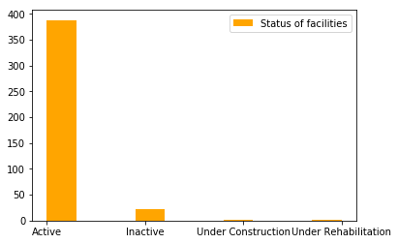

----------------------------------------------------

**Connection closed.**